R-012A
- Tide Gate knocked off and visible on floor of old tide gate chamber, The opening appears to be bricked up nearly to the top.
- Unable to get measurement of overflow elevation
- Float present and in good condition
- Pipe going into float chamber.
- Inlet Chamber: Rim to Outlet Invert= 7’1”
- Tide Chamber: Rim to Outlet Invert =7’10”
- Not able to view old regulator chamber from any manhole
- Date: 12/13/2024 10:45 AM

Revisited on 1/7/2025 around 1:50 pm at high tide. No tidal inflow/infiltration through tide gate opening observed. Tide chamber was partially full.

MH-7038 (dry weather downstream of R-012A)
- Rim to invert: 7’3”
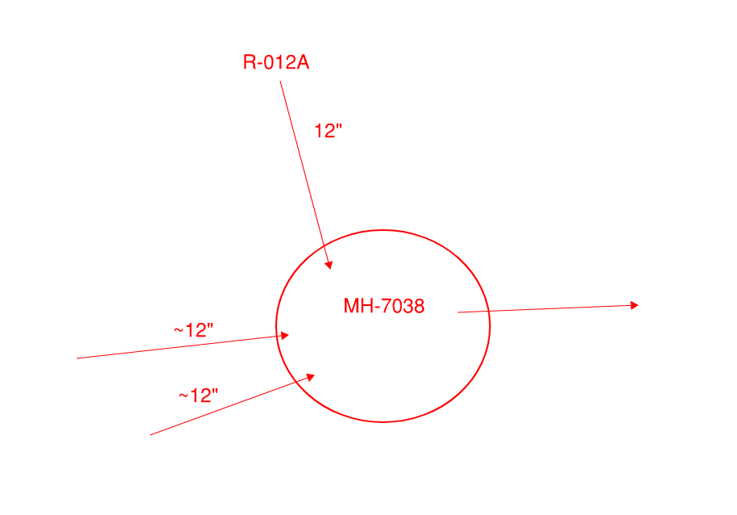
MH-8409 (wet weather downstream of R-012A)
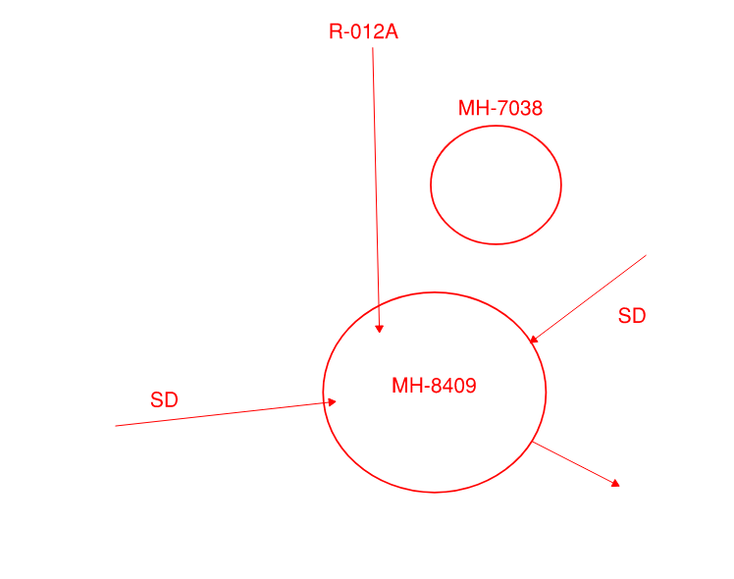

R-012B
- Tide gate sealed shut
- No float
- Inlet Chamber: Rim to Outlet= 6’11”
- Weir height=5”
- Tide gate chamber has two outlets, stacked
  - Rim to Outlet 1=7’9”
  - Rim to Outlet 2=3’11”
Revisited on 1/7/2025 around 2 pm at high tide. Tide chamber not full at all

MH-9370 (overflow from R-012B)
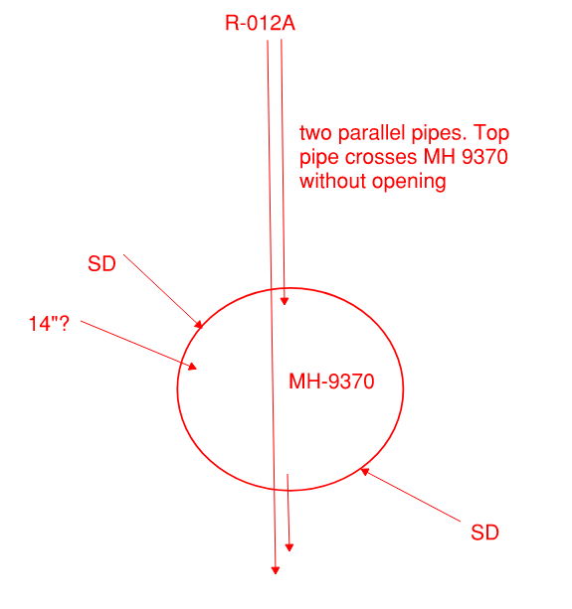
MH-6871 (dry weather downstream of R-012B)
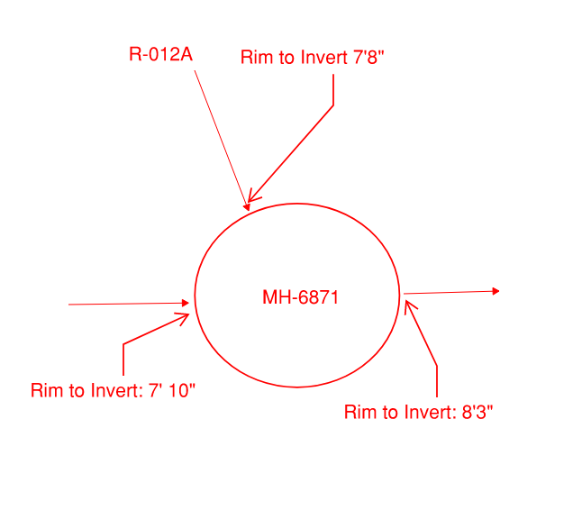
MH-6886
- Rim to Inlet Invert: 7’9”
- Rim to Outlet Invert: 7’10”
- There is a crack in middle of pipe probably causing infiltration

R-013A (See Notes)
- No Float or flow gate
- Block present
- Weir Height= 10”
- Inlet Chamber: Rim to overflow Invert= 5’11”
- Inlet Chamber: Rim to dry weather outlet invert= 6’9”
- Tide Gate in good condition
- Tide Gate: Rim to outlet invert= 6’8”
- Additional opening near top of Tide Gate chamber, Rim to Invert= 3’2”
- Outfall potentially abandoned
MH-7039 (dry weather downstream of R-013A)
- Two sewer inlets
- One outlet
- Rim to invert of inlet from 13A=9’7”
- Rim to invert of other inlet= 9’9”
- Rim to outlet = 10’

MH-7167
- Capped an abandoned. Used to connect to storm drains but does not anymore
MH-7040
- Totally abandoned. 15” Outflow from R-013A runs through the chamber.

R-015A (SEE 15A NOTES)
- Dry weather outlet partially blocked by debris
- Dry weather rim to invert -= 9.9’
- Depth of tide gate chamber = 9.4’
- Woode tide gate appears to be permanently closed by wooden bean propped against it
- Outlet to overflow should be opposite tide gate, but not visible in video
- Two pipe in tide gate chamber, not sure what’s happening here
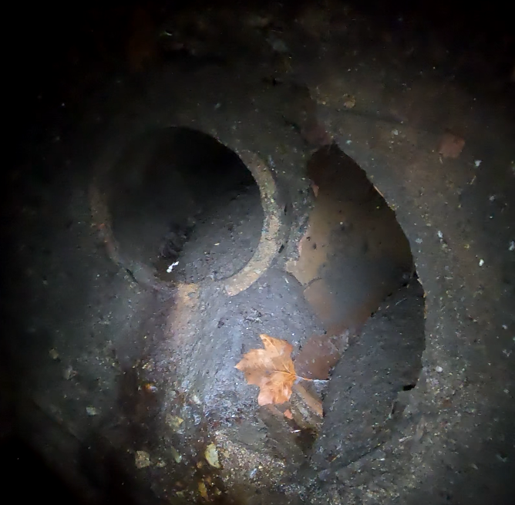
MH-7013
- Only one inlet/one outlet
MH- 7014 (dry weather from R-015A, connects to interceptor)
- Two inlets
- One outlet

R-016A
Downstream of R-016A before outfall (NOT IN GIS)
- Rim to top of duck bill gate = 4’5”
- Rim to inlet invert: 8’1”
- Inlet diam = 2’6”
- Outlet diam=3’

R-017A
- Inlet Chamber: Rim to overflow invert=6’
- Sea water infiltrated in crack long side overflow pipe. Some infiltration through duck bill also.
MH-9255
- No storm drainpipes
MH-7055
- Not visible from surface/could not find

MH-7020
Was probably a regulator in the past but now the overflow is blocked.
- One outgoing 18” pipe
- One incoming 18” pipe

MH-6690
- Cannot locate

R-017C
- Regulator Chamber: Rim to Inlet Invert: 8’
- Inlet Chamber: Rim to DWF outlet invert = 7’7”
- Inlet Chamber: Rim to overflow invert =6’2”
- Sea water infiltration through duck bill into inlet chamber. Gate opening filled and replaced with ~12” pipe
- There are two meters, one in Inlet Chamber and one in old regulator chamber
- Block is in incorrect location- old regulator chamber

R-017D (SEE NOTES)
- Duck bill submerged due to high tide
- Slight inflow through tide gate/duck bill. Potentially a weir before overflow pipe, but not certain.
- Regulator Chamber: Rim to outlet Invert=9’2”
- Inflow near outfall is theoretically from mill toilets

Everything near outfall 41 (SEE NOTES)

R-032A
- No tide gate visible
- Overflow chamber filled with water
- Block string present but block missing
- Weir to Rim: 4.9 ft
- Rim to overflow chamber floor: 12.6ft

R-031E
I believe MH-6520 connects to pipe near top of chamber, which would make it a high level outlet. Infiltration in 2 locations.
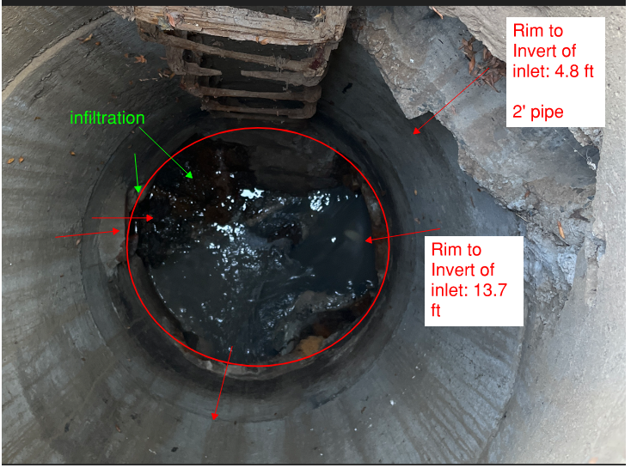

R-31B
- Block present
- 10” outlet to under sewer blocked?
- Rim to weir 3’8”
- No flow gate
- Unclear if 10” pipe to under sewer is capped or not

MH-6520
No flow during field visit.
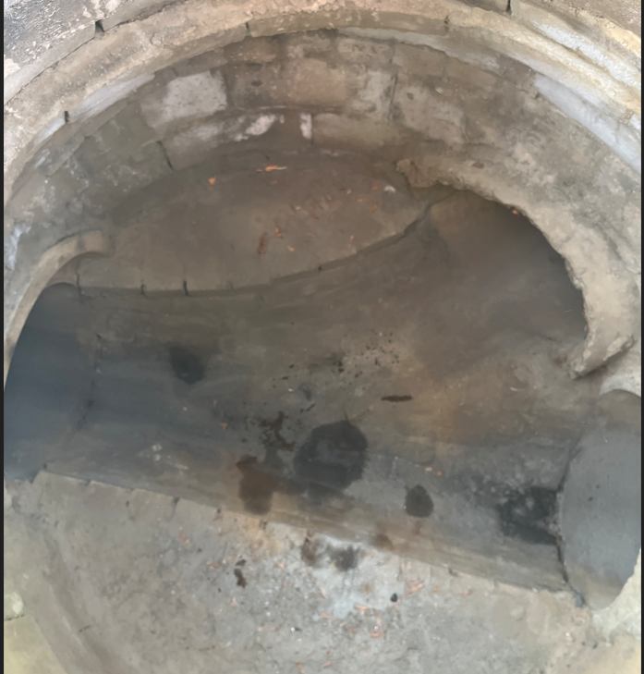

R-034A
- High level outlet (10-12”)
- Rim to inlet= 5’11”
- Rim to dry weather outlet= 7’1”
- Rim to high level outlet= 6’

R-034B
- Rim to wet weather inlet= 7’
- Rim to weir=5’2”
- Spray pained sign on wall of chamber that points to R-024A.
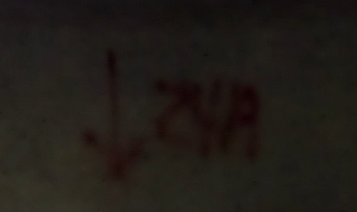

MH-9373
- Dry weather flow, flow continues to R-034A overflow MH (MH-3760)
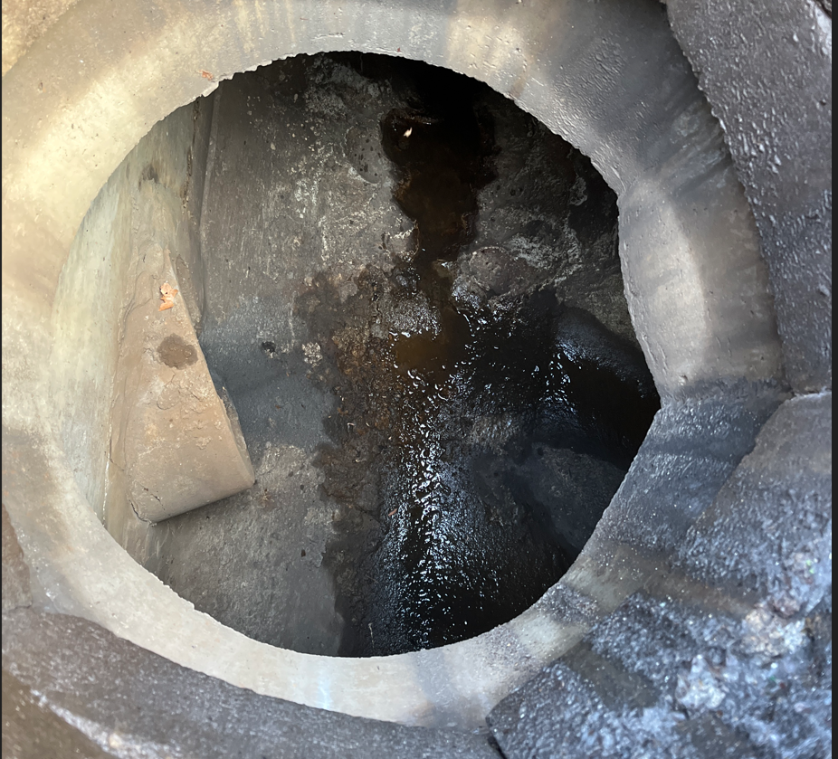

MH-3760 (34A overflow manhole)
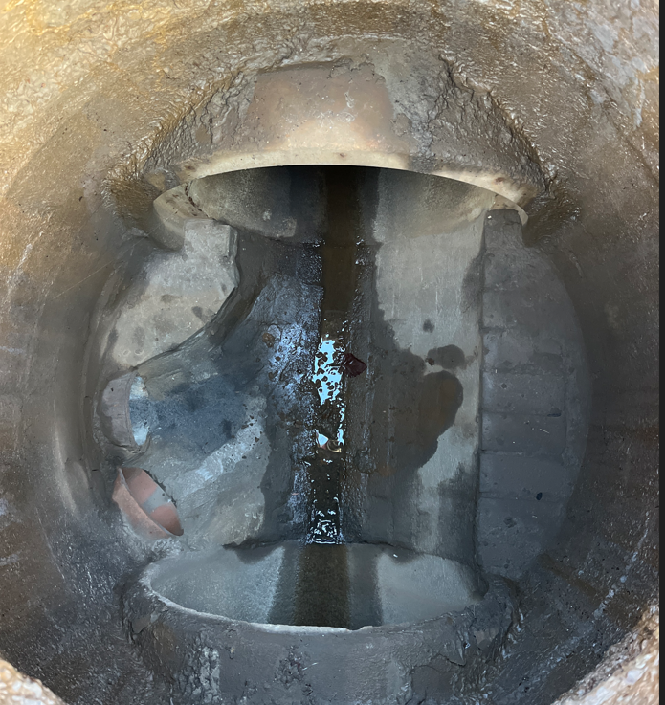

MH-8838
- Maybe some infiltration
- Directly downstream of R-034B
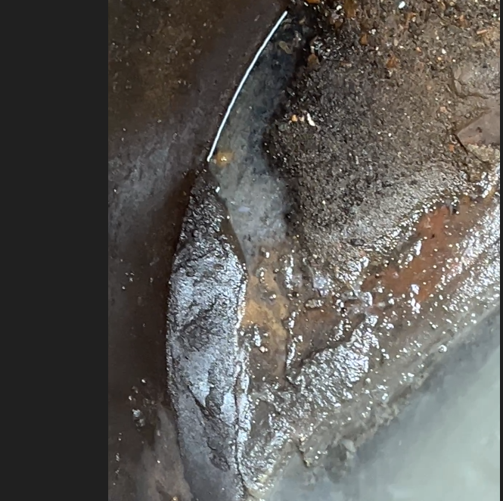
MH-3758
- Dry weather from both R-034B and R-034A. Potentially another inlet, but looks blocked
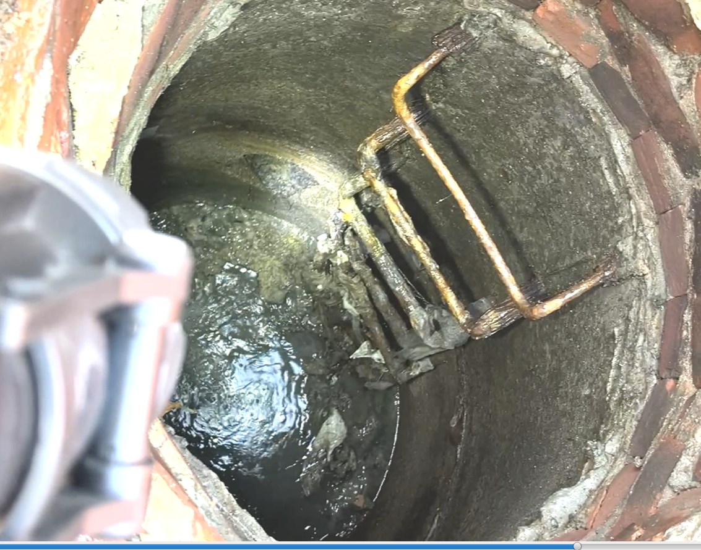

R-023A

MHs- Downstream of R-023A
- Visited 1/15/2023 at low tide. Flow observed going to outfall. Leaking around flap/inline valve. See fieldvisit sketch.
- Two duckbills on 12” pipes
- One inline value on 18”
- See CSO book stetch
- Not in GIS?
Sewer plot is accurate as far as I can tell
https://cmms2.newbedford-ma.gov/nb_dpi/sewer_plot_index/126-150/Sewer_Plot_136.pdf

R-026A
- Looks the same as it did in Dec 2023. Weir with three pipes downstream of regulator before outfall. Would be super easy to take into outfall pipe and investigate it. Not observable from any nearby manholes.
- Block knocked off weir
- Visited 1/10/2024
- Sewer plot is not accurate
- MH with duckbill gate in vicinity- see fieldvisit sketch
- 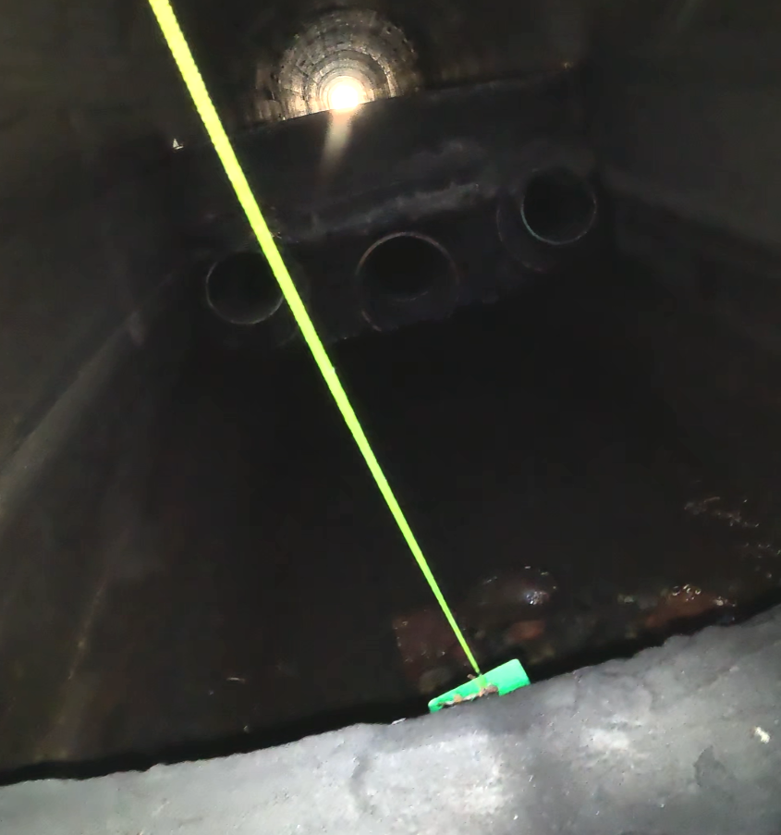

R-024A
- “024A was reconstructed in 2006 under the Earle Street Sewer Separation Project. See attached record plan. There are now tide gates and a new elevated outlet. The model should reflect this. “- Shawn

R-024B
- Dry weather outlet was blocked, and sewer water was overtopping the weir. Notified the city on 1/16/2025. City plans to send someone to unclog the outlet

R-022C
- Rim to overflow outlet: 8.8 ft
- Rim to inlet: 8.7 ft
- Rim to weir: 8.45 ft
- 3” tall weir

R-022H
Covered by aspalt.
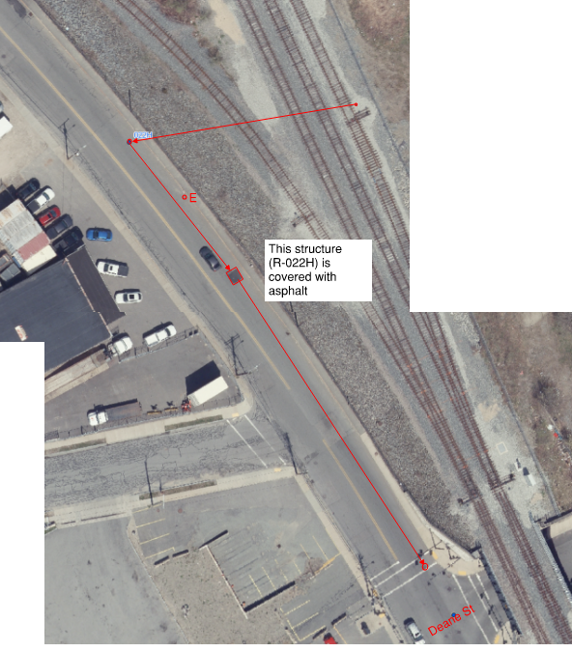

R-035C
Three chamber structure. Standing water in inlet chamber during field visits on 1/10/2025 and Dec 2023. Standing water level above weir. Weir was not visible but we were able to measure it with measuring stick. Weir height approx. 1ft.

Rim to inlet chamber bottom: ~15.5 ft
Rim to top of weir: ~14.6 ft
Looks like a used to have a meter. There is a block but is submerged underwater by heavy debris. Also there is no regulating structure in the outlet chamber so block is in the wrong place. There seems to be another chamber after the outlet chamber (see photos below). This is not accessible without confined space training. I could not confirm the number or size of outlet pipes.

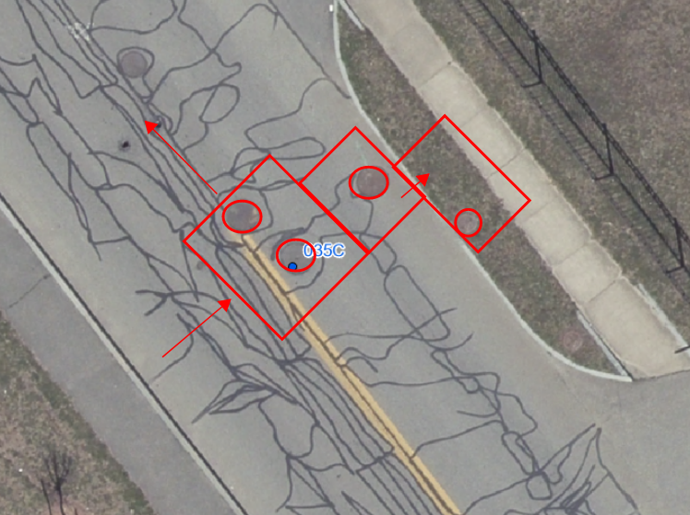

R-036B
For details on R-036B and surrounding manholes, see fieldnotes pdf

